# *Flag background*

* **認識你的權利！**

**阿拉美達工會委員會與 *iAmerica* 合辦誠意邀請你參加誠意邀請你參加**

**移民資源說明展覽會**

**日期：星期六，四月四日，2015年**

**時間：上午十時至下午六時**

**地點：East Bay Community Foundation**

**200 Frank H Ogawa Plaza, Oakland, CA 94612**

***聯絡人: Rosa Advincula-*** [***rosa@alamedalabor.org***](mailto:rosa@alamedalabor.org) ***510.632.4242 ext 223***

* **免費提供法律資源關於的申請程序**
* **免費提供個人十五分鐘的諮詢**
* **即時協助申請健康保險**
* **解釋不論任何移民身份如果可以申請駕駛牌照**
* **提供有關你的權利的資料**
* **免費小吃**
* **免費托兒遊戲區**

**我們的合作夥伴組織**

   https://encrypted-tbn3.gstatic.com/images?q=tbn:ANd9GcRxVPw2xztekH7Hp06yTLmT-FhPncCX4q6yii6AkniM1XmWgQrRug   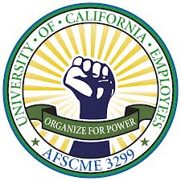  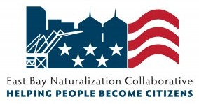

 

Congresswoman Barbara Lee Oakland Council Member Campbell-Washington D4 Assemblymember Tony Thurmond, District 15 Oakland Council Member Gallo D5

Assemblymember Rob Bonta, District 18 Oakland Council Member Brooks D6

Oakland Mayor Libby Schaaf Scott Haggerty, BOS District 1

Oakland Council Member Kalb D1 Richard Valle, BOS District 2

Oakland Council Member Guillen D2 Wilma Chan, BOS District 3

Oakland Council Member McElhaney D3 Nate Miley, BOS District 4

Keith Carson, BOS District 5