# *Flag background*

* ***Alamin ninyo ang inyong mga karapatan!***

**Alameda Labor Council at iAmerica ay iniimbita kayo sa darating na**

***IMMIGRATION RESOURCE FAIR***

**Petsa: Saturday, April 4, 2015**

**Oras: 10am-6pm**

**Lokasyon: East Bay Community Foundation**

**200 Frank H Ogawa Plaza, Oakland, CA 94612**

**Makipag-ugnay sa*: Rosa Advincula-*** [***rosa@alamedalabor.org***](mailto:rosa@alamedalabor.org) ***510.632.4242 ext 223***

* **Libreng legal na payo na nag-specialize sa DACA /DAPA**
* **Libreng 15 minuto konsultasyon at payo**
* **Libreng tulong sa pag-aplay sa health insurance**
* **Paano mag-aplay para sa lisensiya sa pagmamaneho nang walang kinalaman sa iyong immigration status**
* **Impormasyon sa iyong mga karapatan**
* **Libreng pagkain**
* **Lugar para sa mga bata**

**Ang aming mga kasosyo**

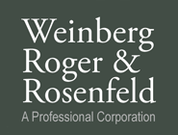   https://encrypted-tbn3.gstatic.com/images?q=tbn:ANd9GcRxVPw2xztekH7Hp06yTLmT-FhPncCX4q6yii6AkniM1XmWgQrRug  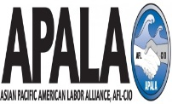 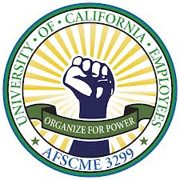  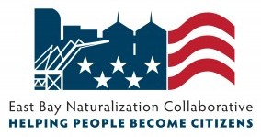

 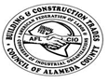

Congresswoman Barbara Lee Oakland Council Member Campbell-Washington D4 Assemblymember Tony Thurmond, District 15 Oakland Council Member Gallo D5

Assemblymember Rob Bonta, District 18 Oakland Council Member Brooks D6

Oakland Mayor Libby Schaaf Scott Haggerty, BOS District 1

Oakland Council Member Kalb D1 Richard Valle, BOS District 2

Oakland Council Member Guillen D2 Wilma Chan, BOS District 3

Oakland Council Member McElhaney D3 Nate Miley, BOS District 4

Keith Carson, BOS District 5