# http://cdn.evbuc.com/images/5510219/3188166028/1/logo.jpg*Flag background*

**날짜: 2015년 4월 4일 토요일**

**시간: 10am-6pm**

**장소: East Bay Community Foundation**

**200 Frank H Ogawa Plaza, Oakland, CA 94612**

**연락처*: Rosa Advincula-*** [***rosa@alamedalabor.org***](mailto:rosa@alamedalabor.org) ***510.632.4242 ext 223***

***Emily Park –*** [***epark@ahschc.org***](mailto:epark@ahschc.org) ***510.986.6830 ext 304 (한국어)***

* **Know Your Rights!**

**여러분이 받을 수 있는 혜택에 대해 알아보세요!**

**iAmerica와 Alameda Labor Council, AFL-CIO 에서 여러분을 초대합니다.**

**IMMIGRATION RESOURCE FAIR 이민 설명회**

* **DACA (청소년추방유예조치)/DAPA(부모추방유예조치) 관련 무료 법률 정보**
* **전문가와 1:1 무료 상담 (15분)**
* **건강보험 혜택 정보**
* **운전면허 발급신청에 대한 정보 (AB 60)**
* **현재 받을 수 있는 다른 혜택**
* **무료 점심 제공**
* **어린이 놀이공간**

**주최 단체들**

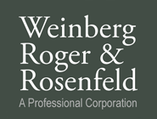   https://encrypted-tbn3.gstatic.com/images?q=tbn:ANd9GcRxVPw2xztekH7Hp06yTLmT-FhPncCX4q6yii6AkniM1XmWgQrRug  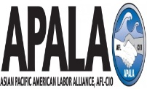 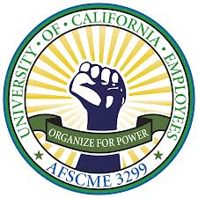  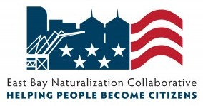





Congresswoman Barbara Lee Oakland Council Member Campbell-Washington D4 Assemblymember Tony Thurmond, District 15 Oakland Council Member Gallo D5

Assemblymember Rob Bonta, District 18 Oakland Council Member Brooks D6

Oakland Mayor Libby Schaaf Scott Haggerty, BOS District 1

Oakland Council Member Kalb D1 Richard Valle, BOS District 2

Oakland Council Member Guillen D2 Wilma Chan, BOS District 3

Oakland Council Member McElhaney D3 Nate Miley, BOS District 4

Keith Carson, BOS District 5