# *Flag background*

* ***Know Your Rights!***

***Alameda Labor Council, AFL-CIO in partnership with iAmerica invites you to***

***IMMIGRATION RESOURCE FAIR***

**Date: Saturday, April 4, 2015**

**Time: 10am-6pm**

**Location: East Bay Community Foundation**

**200 Frank H Ogawa Plaza, Oakland, CA 94612**

***Contact: Rosa Advincula-*** [***rosa@alamedalabor.org***](mailto:rosa@alamedalabor.org) ***510.632.4242 ext 223***

* ***FREE Legal resources specializing on DACA/DAPA process***
* ***FREE One on one 15 minute consultation and advice***
* ***FREE On-Site Health Insurance Benefits Intake***
* ***FREE Learn how to apply for driver’s license regardless of your immigration status***
* ***FREE Information on your rights***
* ***FREE Food***
* ***Kids Area***

**IN COLLABORATION WITH**

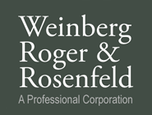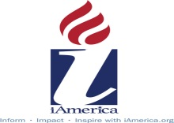   https://encrypted-tbn3.gstatic.com/images?q=tbn:ANd9GcRxVPw2xztekH7Hp06yTLmT-FhPncCX4q6yii6AkniM1XmWgQrRug  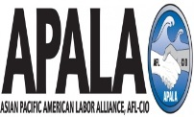 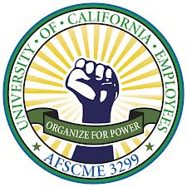  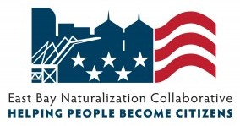

 

Congresswoman Barbara Lee Oakland Council Member Campbell-Washington D4 Assemblymember Tony Thurmond, District 15 Oakland Council Member Gallo D5

Assemblymember Rob Bonta, District 18 Oakland Council Member Brooks D6

Oakland Mayor Libby Schaaf Scott Haggerty, BOS District 1

Oakland Council Member Kalb D1 Richard Valle, BOS District 2

Oakland Council Member Guillen D2 Wilma Chan, BOS District 3

Oakland Council Member McElhaney D3 Nate Miley, BOS District 4

Keith Carson, BOS District 5